**Module – 4**

**Name: Nukala Ayyappa Bharhwaj**

**Batch Id: DSWDMCOS 21012022**

**Problem 1**: Divide 743 by 2 and obtain the result such that the output gives us a value without the decimal point.

**Ans: 372.**

**Problem 2:** Print a 3*4 array of three dimensions, which has the input of vectors sequencing from 13554:13590 **and index the second row and third column element of third dimension of the array**.

Ans: The above question is executed in R and the same file is attached.

**Problem 3:** What is the command to install a package in R and how do you invoke it?

**Ans:** install.packages(“package name”)

library(package name)

**Problem 4:** Create an if statement that prints the name of the team that won.

* Where Team A scored 678 (out of 700), Team B scored 666 (out of 700).

Ans: The above question is executed in R and the same file is attached.

**Problem 5:** Check whether the given number is positive and divisible by 5 or not using conditional statements. (**Hint:** Use both if and else statements)

Given number: 468

Ans: The above question is executed in R and the same file is attached.

**Problem 6:** Given is a formula of Normalization.

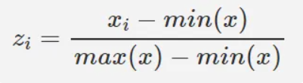

Create a user defined function ‘z’ such that you define the given formula within it.

Where, using **max(x)** and **min(x)** in R gives you the minimum and maximum value of x.

**Ans:** A user defined function for normalization is created in R Programming and the same is attached.

**Problem 7:** If ‘a’ is the given vector. What is the output when you apply the user defined Normalizing function ‘z ()’ to it? [**Hint:** This question is the continuation of **Problem 6]**

**a<-c(33,434,242,434354,545,54,56,56,4534,5342,24,5,65,65,767,8,78,79,79,64,635,3,4,35,57,678,5,86,86,457,546,34,345,34,3,4,65,6,57, ,347)**

**Ans:** Normalization for the above data is done using R Programming and the same is attached.

**Problem 8:** Achieve a Boxplot, Histogram and scatter plot on a given data ‘Q1’. Use any column/columns to get the respective outputs.

**Ans:** Box Plot, Histogram and scatter plot is made for two columns using R programming and the output figure are as below:

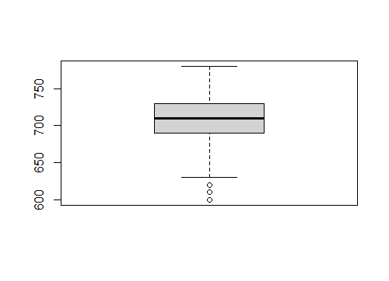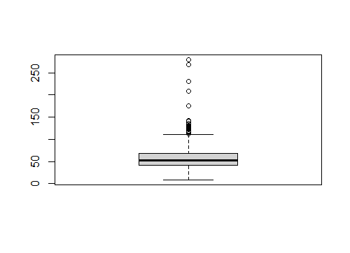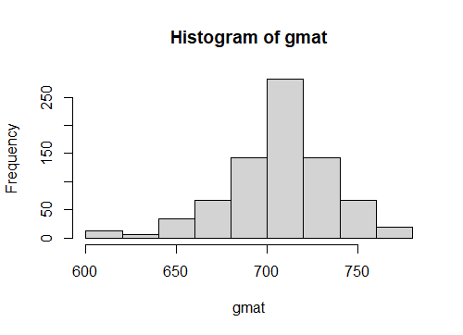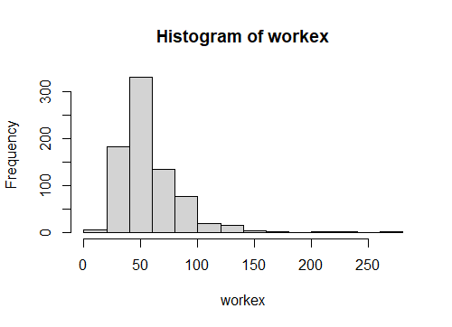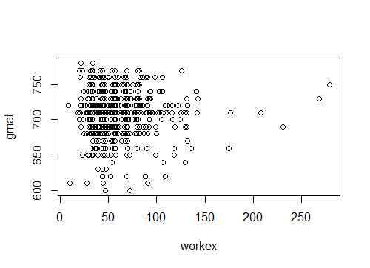

**Note:** Use R to solve the given problems in the above. After you do so, cut and paste your input and output from R to Word, else you can submit your code file along with the question and the question number. If you are sending it in a word file add numbering in Word to identify each part of each problem. (Do this for every problem from now on.)